Log Enrichment/Auto_Queue_Service- Workflow
GitLab Code Repo—

Folder Structure ---
Below shows folder structure is python based
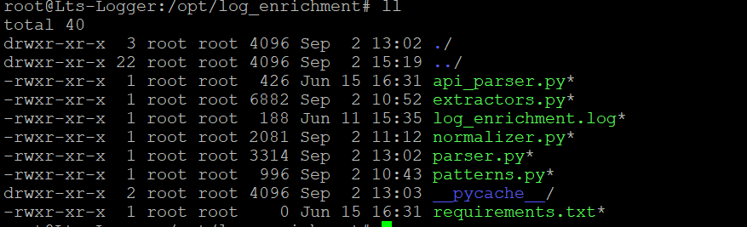
And there is connectivity with queue service in java code which is completely built deployable jar file
/opt/ AutoAlarmQueueServiceV4.1.jar
Git lab url code- https://gitlab.leotechnosoft.net/UjwalaB/vsocbox-features2k26/-/tree/main/GraylogUpdatedFeature?ref_type=heads
Config File Path-
/opt/AutoAlarmConfigFiles
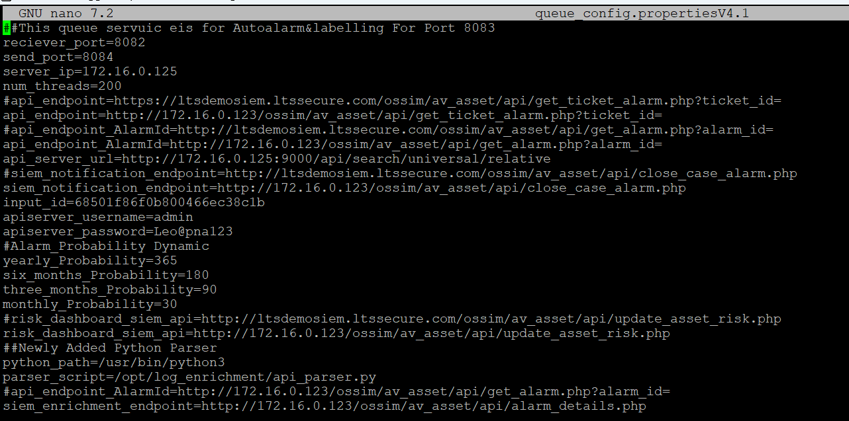

Parameters Need To Be Configure-
send_port= Graylog UDP Port
server_ip= Graylog Server Ip
api_endpoint= SIEM Api endpoint case_id based log info
api_endpoint_AlarmId= SIEM Api endpoint Alarm_id based log info
api_server_url=Graylog URL
siem_notification_endpoint=Notify SIEM server api
input_id=Graylgo Input ID
apiserver_username=logger api username
apiserver_password= logger api password
risk_dashboard_siem_api=SIEM risk dashboard API
parser_script= Enrichment path
siem_enrichment_endpoint= SIEM Log Enrich endpoint

Deployement Guide
Note—Below is the URL which once we cloned on it any server and run install.sh then all the service will be auto deploy and folder structure will be auto created
Note –Before run install.sh script need to configure the config files which already mention in the readme.
GitLabURL- https://gitlab.leotechnosoft.net/UjwalaB/graylog-platform

